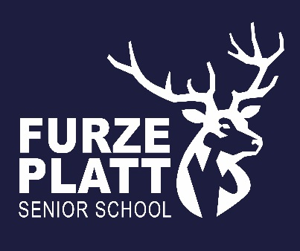

Furze Platt Senior School
Governor Committees and Link Roles
February 2026

Chair of Governors: Katie Mair
Vice Chair of Governors: Hugh Steed

Resources Committee | Quality of Education Committee | Pupils & Parents Committee
Rob Olliff (Chair)  Katie Mair  Chris Rodgers (Vice Chair)  Hugh Steed | Chris Rodgers (Chair)  Daniel Siskin (Vice Chair)  Diane Flood  Abi Stead  Kate Winrow-Davies | Diane Flood (Chair)  Kate Winrow-Davies (Vice Chair)  Nabeela Akhtar  Daniel Siskin  Jo Smith  Mari Ueckermann

Exclusion Panel | Pay and Performance Management Panel
Katie Mair  Hugh Steed  Diane Flood  Nabeela Akhtar  Kate Winrow-Davies  Jo Smith  Rob Olliff | Katie Mair  Hugh Steed  Nabeela Akhtar  Chris Rodgers  Rob Olliff

Governor Link Roles
Attendance | Jo Smith
Careers/CEIAG | Kate Winrow-Davies
Health & Safety | Joshua Reynolds
Pupil Premium and CLA | Katie Mair, shadowed by Daniel Siskin
Safeguarding | Diane Flood, shadowed by Abi Stead and Nabeela Akhtar
SEND | Jo Smith

