


Reporting absences (including medical appointments)

Please use Studybugs to communicate all things attendance related (including medical appointments).

Whilst we appreciate that there is currently no separate option to report medical appointments on Studybugs, we kindly ask that all appointments are recorded in the same way as an ‘absence due to illness’.

These will then be reviewed and amended as necessary on your child’s register.

Please use the icon pencil in square - to report all illnesses

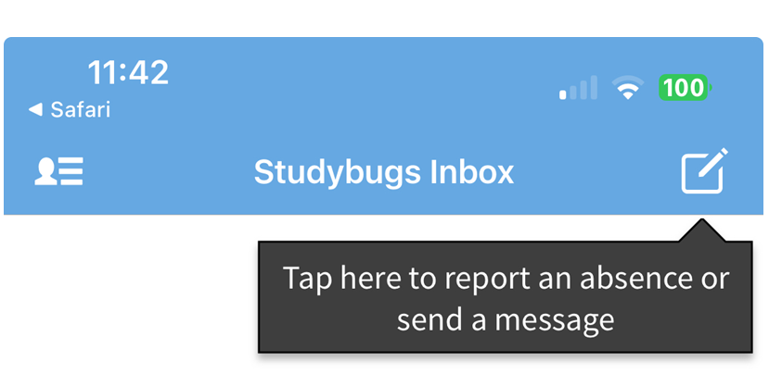

Medical Appointments

Click on ‘Report absence due to illness’ and when asked for your child’s symptoms, please use the answer box, to relay: details of the Appointment, date of the appointment and the time you wish to collect your child or approximate time of their return to school.

(Please note that if a full day is required for a medical appointment, a letter from the Hospital or Orthodontic centre will be required as medical evidence, in order to support the extended time required off school).

With thanks

Attendance Support Team

